Bikhata Birman Prospective Kitten Buyer Questionnaire

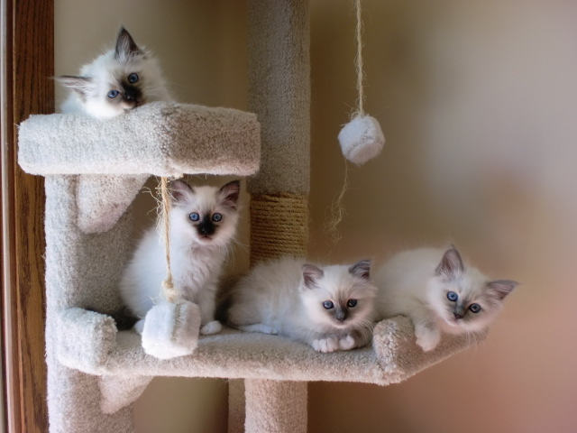

Date:

Name:

Address:

Phone Number:

Email address:

How did you hear about us?

What color and sex of a kitten are you interested in?

Have you ever owned a Birman cat or any cat?

Is anyone in your household allergic to cats or have asthma?

Please tell me about who lives in the household the cat will be living in?

Will the cat be around young children?

Do you have other animals? If yes, please tell me about them. If no, do you plan on getting more than this cat?

What will you do with the cat if you are away from home for a long period of time?

If you were placed in a position where you could not keep the cat, what would you do?

What are your beliefs on declawing cats?

Do you have a Veterinarian that will be taking care of this cat? Is so, please provide contact information for this Veterinarian.

How would this cat get from my home to your home after purchase if not local to me?

Comments:

